B&R unveils a new era in Motion technology at SPS 2025

• Exclusive first look: Witness the global reveal of a new B&R innovation in Motion technology live at SPS.
• Tailored automation solutions: Discover our latest solutions for adaptive manufacturing, smart safety, and Industrial IoT. Experience how openness and modularity unlock new levels of productivity.
• Customer experience: See how intuitive technology accelerates development and enhances usability.

Eggelsberg/Nuremberg – At SPS 2025, B&R Industrial Automation, ABB’s Machine Automation Division, will present a breakthrough in motion technology, designed to help manufacturers master today’s key challenges: shorter product life cycles, increasing customization, and the need for seamless connectivity across machines and systems. The global product launch will take place from November 25–27 at Hall 7, Booth 206, featuring live demonstrations and expert consultations.
Motion technology for evolving industry needs
B&R is preparing to unveil a new motion solution that sets new standards in performance and design. Developed for dynamic production environments, the system is designed to help manufacturers boost productivity, enhance flexibility, and remain competitive in rapidly changing markets. “This innovation marks a significant leap forward in motion control,” says Florian Schneeberger, CEO at B&R, ABB’s Machine Automation Division. “We’ve engineered a solution that not only meets today’s demands but anticipates tomorrow’s challenges, delivering unmatched modularity, openness, and usability.” Built on an exclusive new technologies, the system reflects B&R’s ongoing commitment to modular, open, and user-centric automation. It offers new benchmarks in flexibility, sustainability, safety, and cybersecurity across a wide range of industrial applications. With this innovation, B&R again pushes the boundaries of motion technology, delivering a solution that creates the future and empowers customers to stay far ahead in a highly competitive and rapidly changing world.
Experience innovation firsthand: live demos and expert insights
Visitors to the B&R booth will have the opportunity to experience the new motion system in action and discover the latest innovations through 26 live demonstrations and interactive workstations. Highlights include instant format changeovers, reducing setup from hours to seconds, and synchronized multi-axis motion, cutting energy use while ensuring micro-level precision. B&R experts will be available for in-depth discussions on customized automation solutions tailored to specific production needs. “Every application challenge our customers face is a new starting point for collaboration,” emphasizes Florian Schneeberger. “We work side-by-side with our partners to turn complexity into opportunity and deliver solutions that truly fit their needs.”
A long-term partner in Automation
B&R’s long-standing presence at SPS reflects its commitment to building lasting customer relationships and shaping the future of industrial automation. Through technological innovation and close collaboration, B&R continues to support manufacturers in developing future-ready systems that meet the demands of a rapidly changing market.

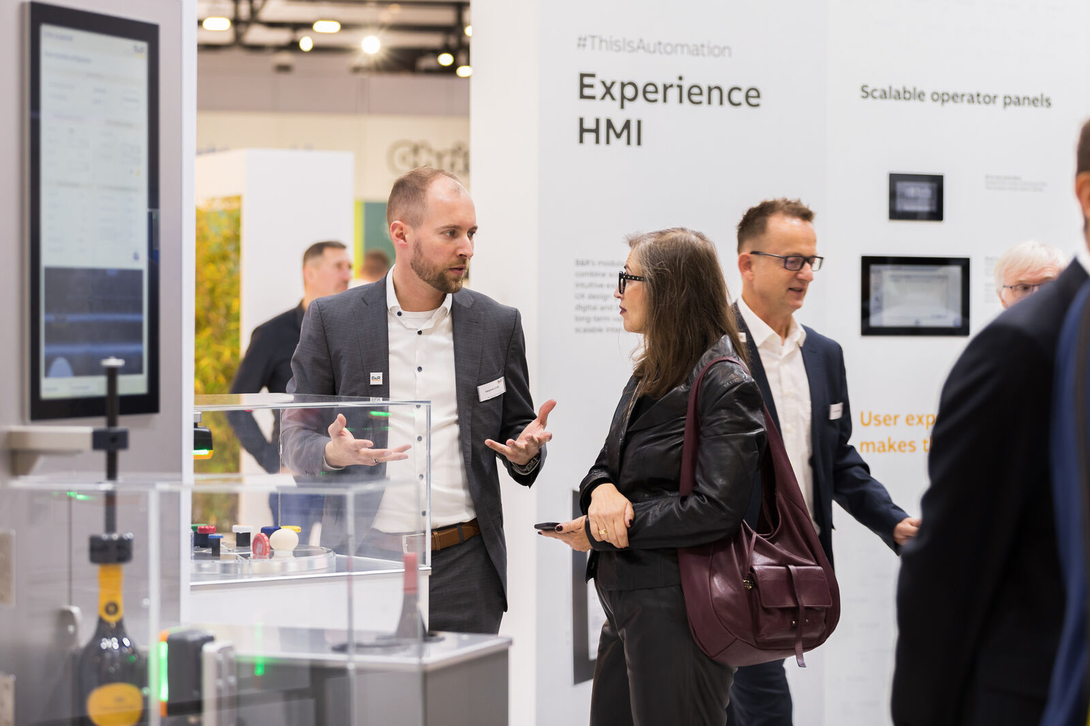
Supporting every industry, B&R technology helps customers improve their machine performance, become more flexible, and stay ahead in a rapidly evolving market. Picture: B&R

About B&R
B&R, a division of ABB Group, is a global leader in industrial automation headquartered in Austria. B&R combines state-of-the-art technology with advanced engineering to provide customers in virtually every industry with complete solutions for machine and factory automation, motion control, HMI and integrated safety technology. With Industrial IoT communication standards including OPC UA, POWERLINK and openSAFETY as well as its Automation Studio software, B&R is constantly redefining the future of automation engineering. The innovative spirit that keeps B&R at the forefront of industrial automation is driven by a commitment to simplifying processes and exceeding customer expectations.
For more information, visit www.br-automation.com.

