Upgraded servo drive reduces cabinet footprint by 50%

Up to 60% increased power range, plus 8x more computing power within the same frame size, makes ACOPOS P3 B&R’s most power-dense servo drives to date.
B&R, the Machine Automation Division of ABB, has enhanced its ACOPOS P3 range to make it one of the most powerful servo drives on the market in terms of absolute computing power and power density. The drive is designed specifically for OEMs serving industries such as plastics, printing, paper, textiles and metal. The ACOPOS P3 range delivers optimized energy consumption, integrated advanced intelligent functions, and simplified, efficient wiring solutions, supporting the design of high performance machines in a remarkably compact footprint. The drive helps OEM customers targeting these markets and others to gain a significant competitive advantage by enabling faster production speeds and better final product quality.
The update expands the power scalability of the ACOPOS P3 family, with seven new devices now available including both single- and double-axis variants ranging from 32-80 kW. As well as increasing the size of the range from two to seven, the double-axis module offers double the power density compared to previous iterations, offering greater choice, functionality, and power scalability for machines.
Upgrades to the drive’s computational power improve responsiveness, resulting in a 50 µs cycle time for all position and speed loops. Advanced intelligent functions can be executed directly within the servo drive, which can operate independently and without being affected by network communication delays or PLC computing performance. This contributes to increased speed and productivity, better final product quality, and improved performance.
A redesigned airflow system, along with coated PCBs, ensure that the drive is robust against external conditions, with dust and other particles present in ambient air circulated away from critical components. Comprehensive thermal monitoring through 17 integrated sensors, allowing the system to operate safely at its performance limits and reducing the need for costly drive oversizing.

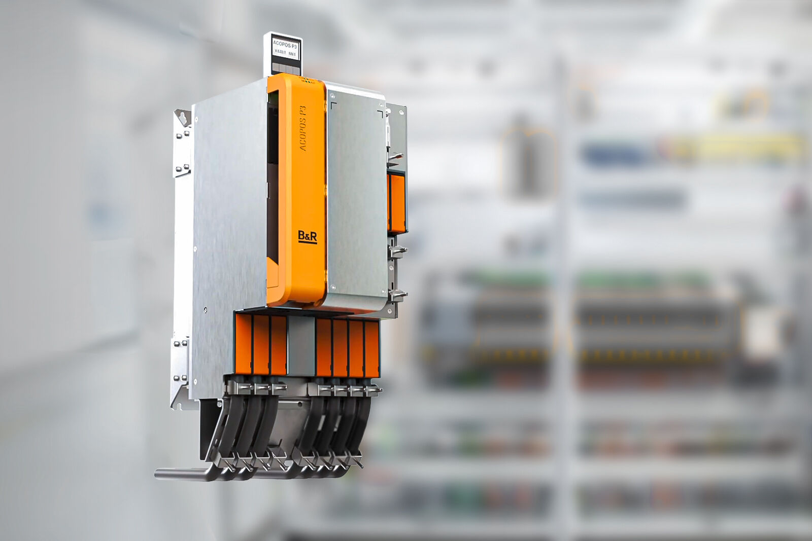
The upgraded ACOPOS P3 servo drive boasts a 50 µs cycle time for all position and speed loops, enhancing responsiveness and productivity.

About B&R
B&R, a division of ABB Group, is a global leader in industrial automation headquartered in Austria. B&R combines state-of-the-art technology with advanced engineering to provide customers in virtually every industry with complete solutions for machine and factory automation, motion control, HMI and integrated safety technology. With Industrial IoT communication standards including OPC UA, POWERLINK and openSAFETY as well as its Automation Studio software, B&R is constantly redefining the future of automation engineering. The innovative spirit that keeps B&R at the forefront of industrial automation is driven by a commitment to simplifying processes and exceeding customer expectations.
For more information, visit www.br-automation.com.

