B&R at SMART Automation Austria 2025
Shaping the Future of Industrial Automation with Innovative Solutions
Join B&R at this year’s SMART Automation Austria event from May 20-22 in Linz, Austria. Visitors to booth 338 will discover how B&R is transforming the industry with cutting-edge mechatronic systems and intelligent software solutions. B&R experts are excited to showcase the latest innovations and discuss tailored automation solutions that meet your unique production needs. Ask our “Automates” at SMART Automation Austria.
At SMART Automation Austria 2025, B&R's focus will be on solution-oriented communication, highlighting how advanced technologies can address specific industry challenges. Visitors will explore how these solutions can transform their production processes and drive business growth.
Customer-Centric Approach for Sustainable Success
Understanding that every production is unique, B&R designs tailored automation solutions to be flexible and adaptable, helping businesses operate more efficiently. By combining powerful hardware with intelligent software, the company supports the optimization of production lines for speed, precision, and sustainability. With decades of expertise and a global network, B&R offers future-proof automation solutions that enhance productivity and sustainability. Michael Humer, Head of Sales Austria at B&R, emphasizes, “We see ourselves not just as a technology supplier, but as a strategic partner to our customers. Our goal is to create sustainable automation solutions that ensure long-term success.”
Empowering Automation with Intelligent Software
The latest software innovations, such as Automation Studio 6, provide a fully integrated development environment for efficient automation engineering. With features like AI-assisted coding and cloud-based engineering, Automation Studio 6 empowers machine builders and system integrators to develop, operate, and maintain complex automation solutions seamlessly. Automation Studio Code, a new development environment, is seamlessly integrated into Automation Studio 6 and fully compatible with existing projects. It offers a modern, user-friendly interface with tools like syntax highlighting, mini-map navigation, and multi-line editing. This extension reduces development times and allows faster market response. “Software is the key to true innovation in automation," says Humer. "With Automation Studio Code, we are setting new standards: intuitive development, seamless integration, and maximum efficiency – this is what the future of engineering looks like.”
Adaptive Manufacturing with Mechatronic Systems
Mechatronic systems such as B&R’s ACOPOStrak are designed to dynamically adapt production processes, enabling flexible manufacturing of products in varying quantities with the highest quality. These systems integrate contactless switches and modular structures, supporting adaptive manufacturing and allowing companies to respond swiftly to market demands. In operation, mechatronic systems excel with rapid changeover times, making downtime largely a thing of the past. Additionally, manufacturing processes can be realized up to 50% faster, significantly increasing productivity, as the elimination of buffer zones greatly shortens the transport distance. “Automation must not be a rigid concept – it must adapt to the individual requirements of our customers,” emphasizes Humer. “B&R develops solutions that help companies remain flexible and efficient in the future.”
Ask about our automated machines. At SMART Automation Austria.

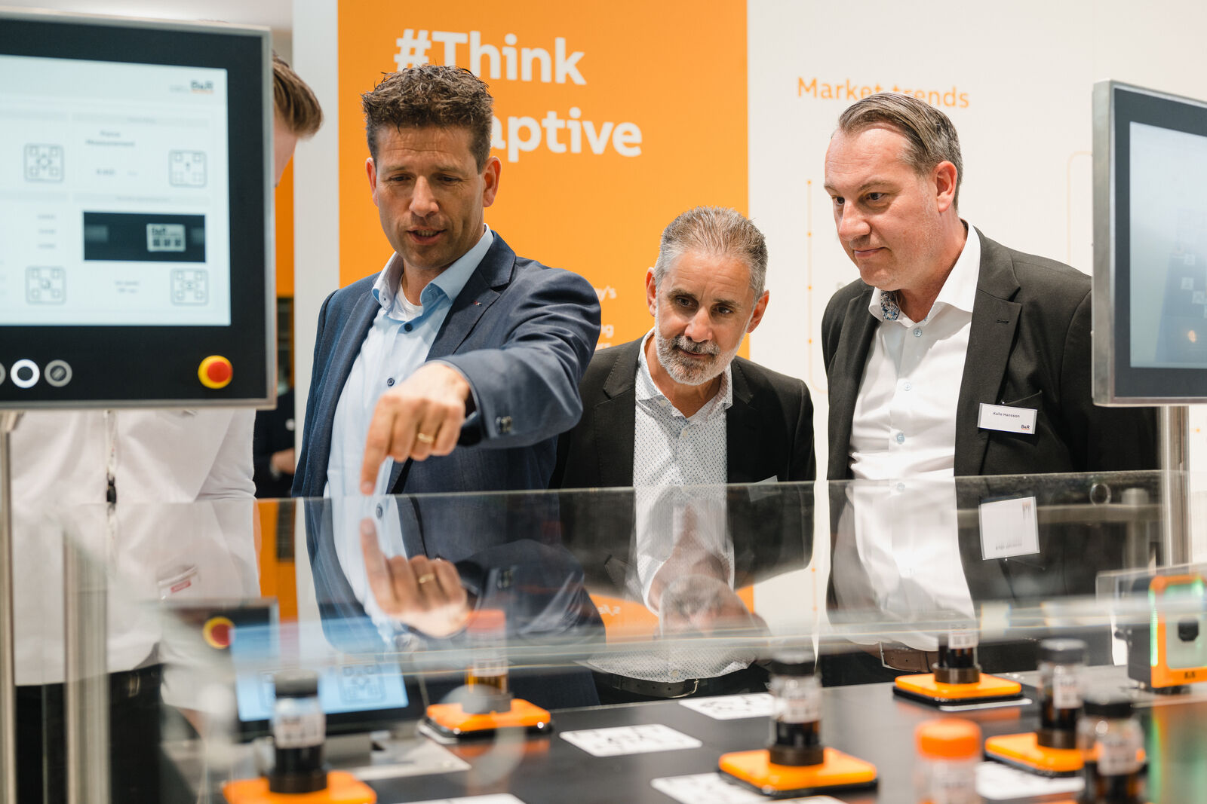
At the show, B&R will present innovative technologies that solve industry challenges and improve production processes. (Image: B&R)
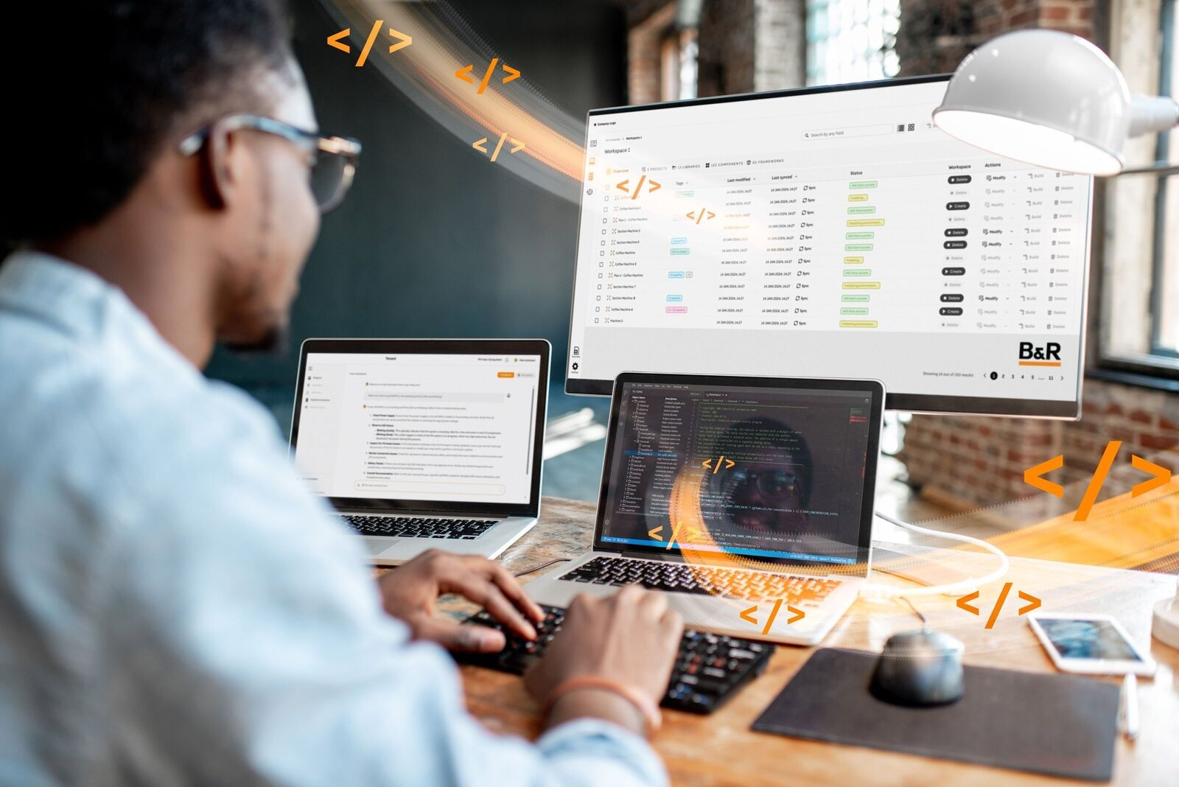
Automation Studio 6 and Automation Studio Code streamline automation engineering with AI-assisted coding and seamless integration. (Image: B&R)

Michael Humer, Head of Sales Austria, B&R (Image: B&R)

About B&R
B&R, a division of ABB Group, is a global leader in industrial automation headquartered in Austria. B&R combines state-of-the-art technology with advanced engineering to provide customers in virtually every industry with complete solutions for machine and factory automation, motion control, HMI and integrated safety technology. With Industrial IoT communication standards including OPC UA, POWERLINK and openSAFETY as well as its Automation Studio software, B&R is constantly redefining the future of automation engineering. The innovative spirit that keeps B&R at the forefront of industrial automation is driven by a commitment to simplifying processes and exceeding customer expectations.
For more information, visit www.br-automation.com.

