B&R at SPS 2024
Connecting products, platforms, and people with open solutions to unlock new levels of productivity
• New version of B&R software accelerates machine development with AI coding assistant and cloud-based engineering
• Industrial IoT apps enable live optimization of performance and energy, predictive maintenance of track systems and more
• Over 150 B&R experts, 20 live demos and 7 interactive workstations invite visitors to explore, experience and discover the future of intelligent machine automation
At this year's SPS event from November 12-14 in Nuremberg, Germany, visitors to Booth 206 in Hall 7 will experience how B&R is helping machine builders, integrators, owners and operators unlock new levels of productivity. More than 150 B&R experts are on hand to show the company's latest innovations – from new AI-assisted coding and cloud-based engineering to interoperable Industrial IoT solutions, AI-enhanced machine vision and a new open approach to safety engineering.
"Whether you're designing machines or operating them, the ultimate goal is always maximum efficiency and productivity. The tricky part is balancing that with the flexibility and simplicity that have become so essential in a world of accelerating complexity, shifting consumer demands, environmental pressures, and interconnected digital ecosystems," says B&R Chief Technology Officer Florian Schneeberger. "That's why every innovation step we take supports our customers in mastering this balancing act – enabling them to achieve both efficiency and flexibility through our advanced, open and interconnected automation solutions."
The B&R booth at this year's SPS event showcases how B&R's commitment to openness helps it connect people, platforms and products to drive productivity. Connecting a comprehensive machine automation portfolio through a global network of experts and partners enables B&R to offer hardware, software and mechatronics that solve real world needs. Open and interoperable solutions connect the B&R ecosystem beyond boundaries – to existing brownfield architectures, multi-vendor ecosystems and new cloud-based tools. "In all cases," notes Schneeberger, "the focus is on connecting each customer to their best solution."
Live and interactive at the B&R booth
Visitors to SPS 2024 will be among the first to get their hands on the new version of B&R's automation software. With an all-new interface featuring AI-assisted coding and flexible cloud-based engineering, it promises to elevate the automation engineering experience with more productivity and better collaboration. At the interactive workstations they can put that claim to the test, as well as trying out B&R's new safety engineering experience with an open code base and a variety of new programming options.
The B&R booth also presents B&R's latest developments in open robot mechanics and mechatronic product transport – including 3D digital twin simulation for conceptual design, capacity optimization and energy balancing. Also on display are B&R's open and interoperable Industrial IoT and edge solutions with AI-powered apps for live optimization of performance and energy, predictive maintenance of track systems and more.
Over 150 B&R experts look forward to guiding visitors through 20 live demos and 7 interactive workstations, where they will experience the power of adaptive manufacturing to fit more flexibility and productivity on a smaller footprint and discover the potential of open standards to deliver more performance, easy scaling and new business models.

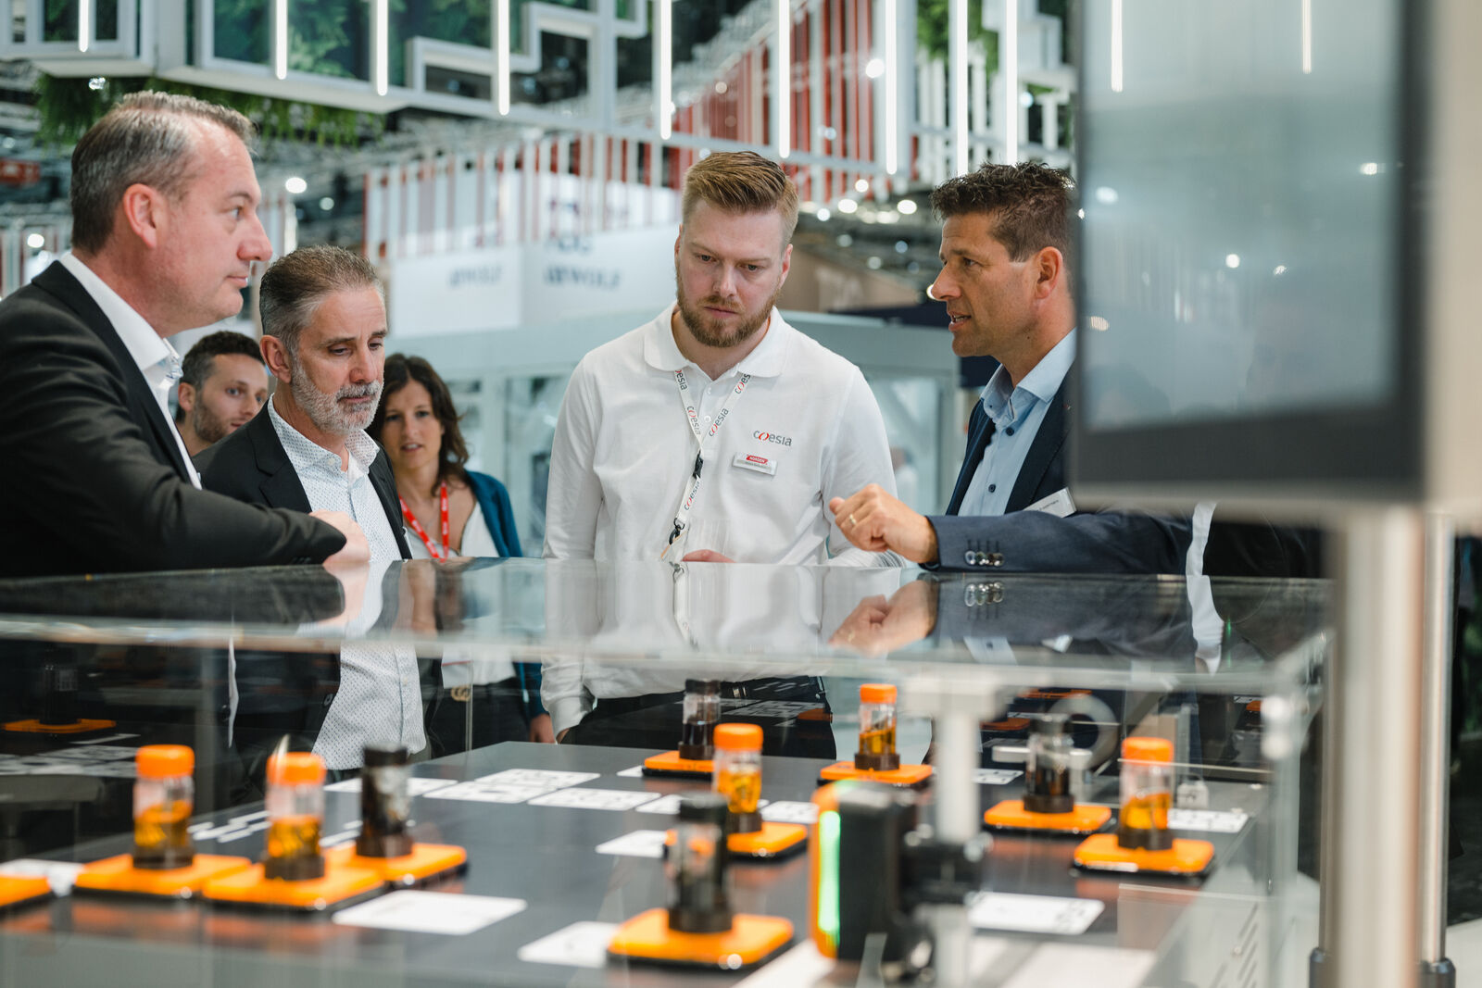
SPS in Nuremberg from November 12-14: In Hall 7, Booth 206, B&R shows how connecting products, platforms and people can unlock new levels of productivity. (Source: B&R)
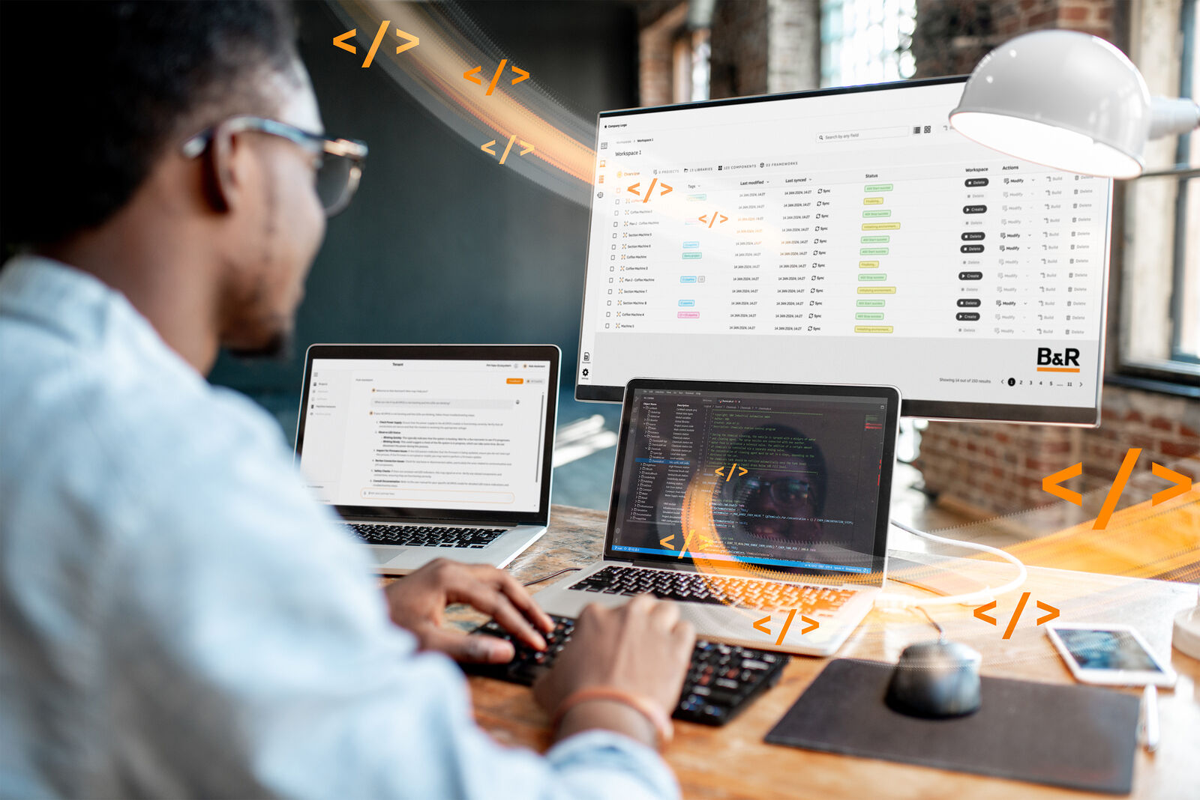
At an interactive workstation, SPS visitors can be among the first to try B&R's new AI-assisted coding and flexible cloud-based engineering. (Source: B&R)
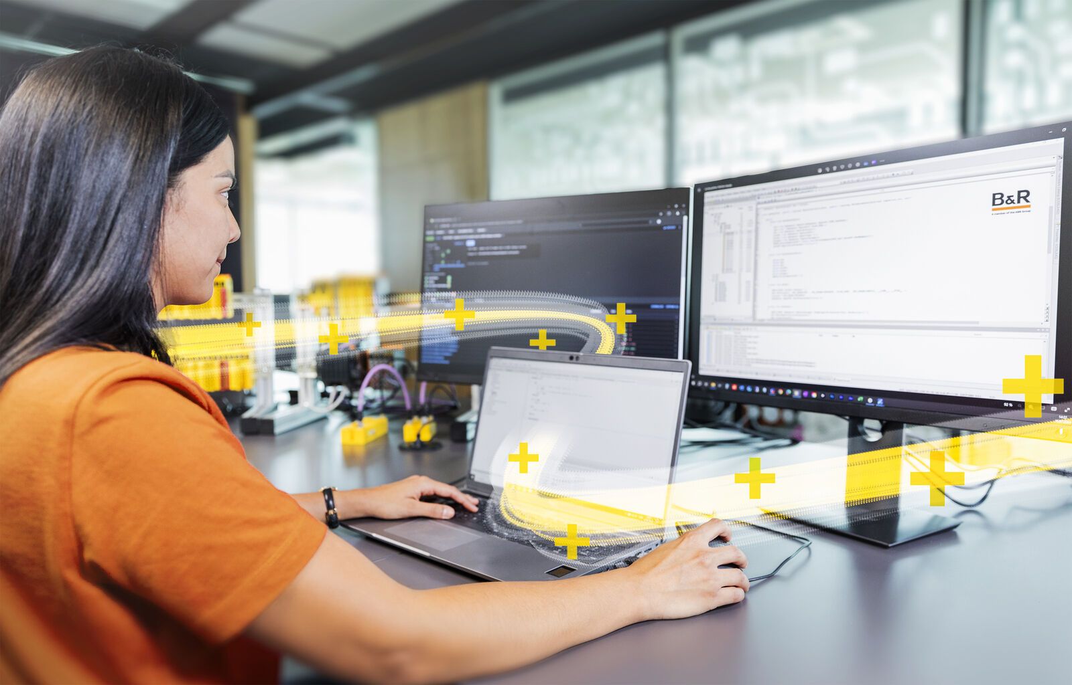
With an open code base and powerful new programming options, B&R aims to bring safety engineering into the smart factory era. SPS visitors can try it live at an interactive workstation. (Source: B&R)

About B&R
B&R, a division of ABB Group, is a global leader in industrial automation headquartered in Austria. B&R combines state-of-the-art technology with advanced engineering to provide customers in virtually every industry with complete solutions for machine and factory automation, motion control, HMI and integrated safety technology. With Industrial IoT communication standards including OPC UA, POWERLINK and openSAFETY as well as its Automation Studio software, B&R is constantly redefining the future of automation engineering. The innovative spirit that keeps B&R at the forefront of industrial automation is driven by a commitment to simplifying processes and exceeding customer expectations.
For more information, visit www.br-automation.com.

